Project Proposal

For

Dragon Friends

Instructor: Andrea Forte
Team Members: | Carter Knight, Victoria Young, Alia Yeszhanova,  Sahithi Pisupati, Tri Le
Cycle: | 1
Date Submitted: | 04/15/2018

Document template copyright 2015, CCI Faculty, Version 2.0. Use permitted under Creative Commons license CC-BY-NC-SA. See http://creativecommons.org/licenses/by-nc-sa/3.0/

Grading Rubric – Project Proposal

This rubric outlines the grading criteria for this document. Note that the criteria represent a plan for grading. Change is possible, especially given the dynamic nature of this course. Any change will be applied consistently for the entire class.

Achievement | Minimal | Exemplary | Pts | Score
Content | Section(s) missing, not useful, inconsistent, or wrong. | Provides all relevant information correctly and with appropriate detail
Project |  |  | 30
Team |  |  | 10
Timeline |  |  | 30
Grammar and Spelling | Many serious mistakes in grammar or spelling | Grammar, punctuation, and spelling all correct | 10
Expression | Hard to follow or poor word choices | Clear and concise. A pleasure to read | 10
Tone | Tone not appropriate for technical writing | Tone is consistently professional
Organization | Information difficult to locate | All information is easy to find and important points stand out | 10
Layout | Layout is inconsistent, visually distracting, or hinders use | Layout is attractive, consistent, and helps guide the reader
Late Submission
Total |  |  | 100

Project Proposal

This report documents the initial definition of the project. It includes an abstract and project overview. It also includes a summary of issues related to the project and to the team.

Project

Project Name: Dragon Friends

Abstract
For our project, we present the idea of the DragonFriends, a mobile application that reinvents how students find and meet peers in their new classes. As freshman, our team members have often gone through a phase in the beginning of the term when we scoured for our friends in the same courses. Rather than individually texting contacts or posting your schedule via social media, our application simplifies the entire process and helps prepare students for the term ahead.
Through DragonFriends, students can create a profile by providing their Drexel credentials. After, they will be prompted to input their schedule which is then matched with other users’ classes in the database. The student will then receive a roster of people who are also enrolled in their courses. From there users can engage in group chats or contact others individually, eliminating the anxiety of starting a new term and allowing people to network with one another upfront and throughout the year.

Project Deliverables

In terms of authentication, the system will allow Drexel students only to sign up. This can be done by email verification. For sarching and adding classes, the system will allow Drexel students to add the classes they currently have using a search function from a database of all classes in that quarter. To view other students in the same class, the system will also allow those in the same class to see each other, and their contact information if they choose to make it public.

Resources

In terms of software, we need Android Studio to develop the Andriod App. Also, we need access to list of classes of Drexel Term Master Schedule. In terms of hardware, we need an Android phone for testing and a USB cord to connect it.

Expertise

We need expertise in Java development, especially Android development in Android Studio. We also need expertise in Firebase, since we are using Firebase as our database backend.

Team

Team Members and Roles

Figure 1, below, identifies all the team members and the initial role assigned to each person.
Name | Role
Carter Knight | Project Manager
Tri Le | Application Developer/Support Manager
Alia Yezhanova | Application Developer/Technical Designer
Sahithi Pisupati | Application Developer/Technical Designer
Victoria Young | Application Developer/Technical Designer
Figure 1 - Team Members and Roles

Timeline

The figure below shows the initially identified set of activities for this cycle.

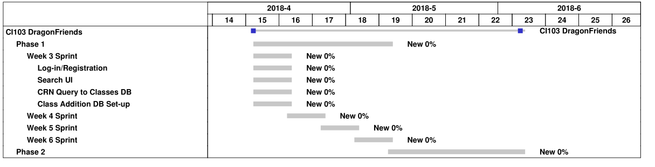

Figure 2 – Project Timeline

